Ideation Phase
Define the Problem Statements

Date | 08 July 2026
Team ID
Project Name | Sports Hall Booking System
Maximum Marks | 2 Marks

Customer Problem Statement Template:

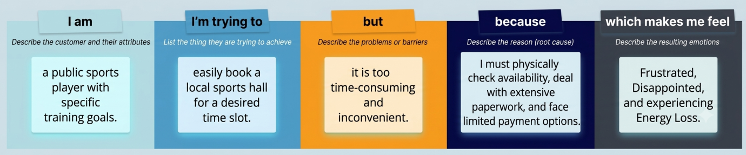

Problem Statement (PS) | I am (Customer) | I'm trying to | But | Because | Which makes me feel
PS-1 | A student who wants to play sports | Book a sports hall for practice | I don't know whether the hall is available | There is no online booking system | Frustrated and confused
PS-2 | A sports club member | Reserve a specific time slot | Someone else has already booked it without my knowledge | Manual booking records are not updated in real time | Disappointed and inconvenienced
PS-3 | A regular sports player | Complete my booking quickly | I have to visit the sports office every time | The booking process is completely manual | I feel that the process is slow and time-consuming
PS-4 | A student | Check booking charges before reserving a hall | The charges are not displayed clearly | There is no centralized booking platform | Uncertain about the booking process
PS-5 | A user who has completed a booking | Verify that my reservation has been recorded | I don't receive any immediate confirmation | The manual system does not provide instant updates | Unsure whether my booking is successful

